## Project Tender

# Project: Chat for Linphone

Kobus Coetzee

Team: Men at Work

Ivan Henning ()

Muller Potgieter ()

Johan van Rooyen (11205131)

Herman Keuris ()

?? ()

Department of Computer Science, University of Pretoria

Date: 2015-05-04

Photo

# The Team

## Ivan Henning

### Interests

### Technical Skills

### Past Experiences

### Non-technical Strengths

### What makes you want to do the project?

## Joseph Muller Potgieter

### Interests

### Technical Skills

### Past Experiences

### Non-technical Strengths

### What makes you want to do the project?

## Johan van Rooyen

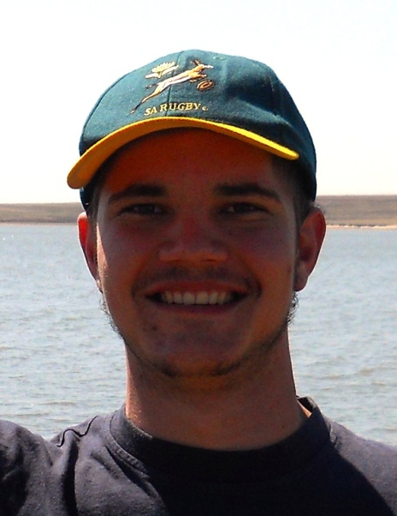

### Interests

* Fishing
* Hunting
* Adrenaline sports
* Computer Games
* Website design
* Electronic components and building small appliances

### Technical Skills

* C++ and C
* Java
* HTML, CSS and Javascript Coding
* PHP Development
* SQL Programming (Database Management)
* Novice Android Development
* Technical Support

### Past Experiences

* Worked as a web developer for 12 months in 2011, writing new and editing existing sites, managing resources on a remote server and working in weekly sprints to finish the project.
* Worked with an international team on a web design project, where meetings took place over Skype and collaborating through an private server made transfer of resources possible.

### Non-technical Strengths

* Good Communication skills
* Collaborate well with a team
* Good business knowledge
* Knowledge of Law in South Africa
* Good time management
* Organizational and Management skills
* Great problem solving abilities
* Go-getter

### What makes you want to do the project?

## Herman Keuris

### Interests

### Technical Skills

### Past Experiences

### Non-technical Strengths

### What makes you want to do the project?

## ??

### Interests

### Technical Skills

### Past Experiences

### Non-technical Strengths

### What makes you want to do the project?

# Project Execution